INFORMATION SYSTEMS: ICE TASK 3
Group 7: Thamsanqa Nkosi Ncube - ST10482062 Kandyce Smit – ST10467645

Lecturer: Moses Olaifa
Module: INSY6211

Table of Contents
Scenario 1 – Kandyce Smit (ST10467645) 2
➢ Identify the domain classes and describe each of the identified classes: 2
➢ Design a domain model class diagram for each of the scenarios. Among others, indicate the class name, attributes and multiplicity for each class in the model class diagram: 3
Scenario 2 – Thamsanqa Ncube ST10482062 4
Identify the domain classes and describe each of the identified classes: 4
Design a domain model class diagram for each of the scenarios. Among others, indicate the class name, attributes and multiplicity for each class in the model class diagram: 4

Scenario 1 – Kandyce Smit (ST10467645)

Identify the domain classes and describe each of the identified classes:
- Patient - A person getting medical care from the hospital in which their information (personal & medical) needs to be saved.
- Doctor - The healthcare professional that sees the patient, gives them prescription(s) and manages follow up visits with the patient.
- Receptionist - A hospital employee that is responsible for managing the check-in process for patients; scheduling appointments for patients; retrieving patient files.
- Appointment - An appointment time when a patient will meet with a doctor as part of an initial visit or a follow-up visit.
- Prescription - A written order created by a doctor to provide the name and quantity of prescribed medicine for the patient after the patient has been seen by the doctor during a consultation.
- MedicalRecord - Electronic copy of all past visits made by a patient and his/her complete medical history including diagnosis and treatment.

Design a domain model class diagram for each of the scenarios. Among others, indicate the class name, attributes and multiplicity for each class in the model class diagram:

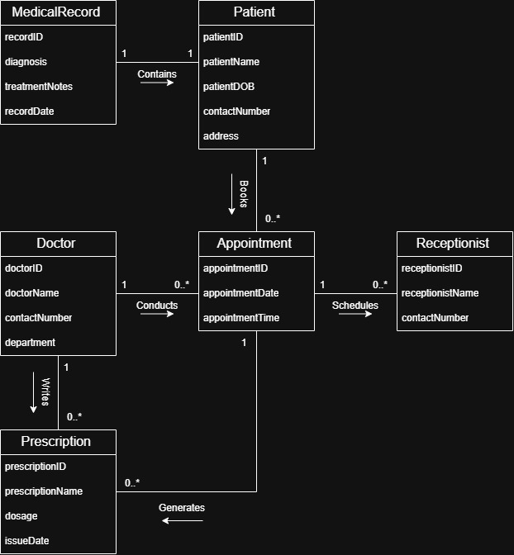

Scenario 2 – Thamsanqa Ncube ST10482062

Identify the domain classes and describe each of the identified classes:
The domain classes identified are:
- Intersection: Point where 2 or more roads meet. It contains traffic lights and servers as a location for traffic flow monitoring
- TrafficFlowData: Time-stamped record of traffic conditions at an intersection, which includes: vehicle count, average speed and occupancy
- TrafficLight: Signalling device at an intersection that controls vehicle flow via the use of coloured phases (red, yellow, green) with programmable durations.
- RoadSegment: Stretch of road that connects 2 intersections, which is characterized by, length, number of lanes and speed limit

Design a domain model class diagram for each of the scenarios. Among others, indicate the class name, attributes and multiplicity for each class in the model class diagram:
